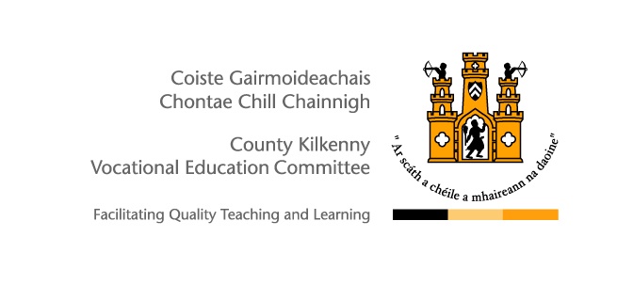

Self Certified
Sick Leave Form

Members of staff must complete a self-certified sick leave form for all periods of absence due to illness which are not covered by a medical certificate.

Please note that the maximum number of self-certified sick leave days allowable in any rolling period of 2 consecutive years is 7 days (full-time equivalent). Therefore, all absences in excess of 7 days in 2 years must be certified.

This form should be completed by the employee, signed by the School Principal/Head of Centre (or Designated Officer) and returned to the Human Resource Department, Kilkenny and Carlow ETB, Seville Lodge, Callan Road, Kilkenny on return to work.

Employee’s  Name: |  | School/  Centre:
I confirm that because of ill health I was unable to attend work.

From: _____________________________________________________(dd/mm/yyyy) To:_________________________________________________(dd/mm/yyyy)

*Total Number of Days Absent: ____________________________________________________________________

Employee’s  Signature: |  | Date:
School Principal/  Head of Centre |  | Date:
*Please note that where a member of staff is absent on a Friday and on the following Monday, the absence will be recorded as 4 days sick leave and a medical certificate will be required.

For further information on Sick Leave please refer to:
- Sick Leave Scheme for SNAs - Circular 0054/2015
- Sick Leave Arrangements for all staff (excluding Teachers & SNAs) – Circular 0063/2015
- Sick Leave Arrangements for Teachers - Please refer to the Terms & Conditions of Employment for Registered Teachers available on the Department of Education and Skills website www.education.ie

