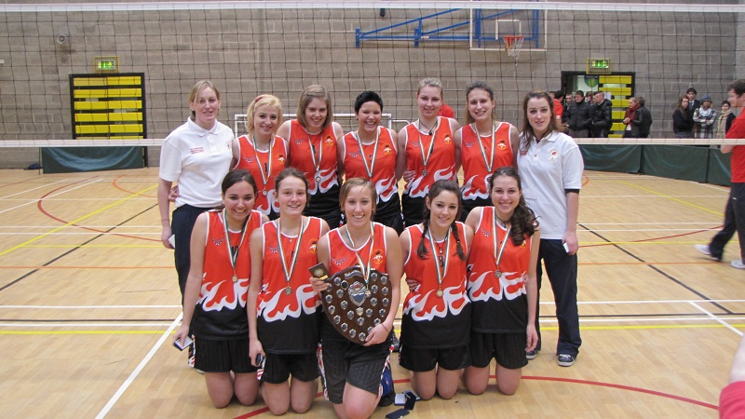

Carlow Vocational School wins the All Ireland Senior C Girls Volleyball Final
Carlow Vocational School has won the All Ireland Senior C Girls Volleyball final. On Thursday 8 December our senior girls travelled to the UCD arena to play in the Volleyball final against Terenure Presentation. This was the first year for our school to enter the competition but the team showed their true talent with the help of their coaches Ms Mary Walsh and Ms Martina Redmond and won the all Ireland competition with a score of 25-22 in the first set and a score of 25-15 in the second set. The senior girls took the first set but Terenure presentation fought back bravely in the second set but they were no match for the Carlow Vocational School girls.
The Captain of the team Stefania Sirignano collected the shield on behalf of her team mates but she also collected the award for Most Valuable Player for her outstanding performance on the day. The team comprised of Claudia Campestrini, Natalie Declara, Laura Giacobbi, Selina Milanovic, Monica Pedron, Eugenia Scanferla, Stefania Sirignano, Verena Vorhauser, Eleonara Zanetti, Samantha Zoschg trained very hard all year and due to their hard work were awarded this well deserved All Ireland VolleyBall title. The staff at carlow vocational school want to congratulate the team and their coaches on a wonderful achievement.

