Leinster Final Victory for the Abbey
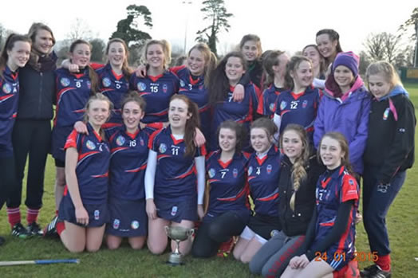
Saturday, 24th January was a great day in the annals of Abbey Community College. Abbey Senior Camogie Team won the Leinster Final defeating St. Josephs, Rochford Bridge, in Fenagh Co. Carlow. by 4 goals 6 points to 3 goals and 5 points.
On the day, the Abbey team were the underdogs but they fought hard from the start. By half time they were up by two points largely due to two brilliant goals scored by Iona Heffernan and Anne Marie O’Neill.
The beginning of the second half saw a huge onslaught by St. Joseph’s who led by 6 points at one stage. The Abbey’s luck took a turn for the better with the goal scored by Anne Marie O’Neill who really lifted the spirits of the Abbey team. Hannah Irish came in as sub and thrilled the team by scoring a goal.
Other scorers on day were Shannon Doyle and Danielle Dempsey with Niamh Aherne scoring the final point.
For an outstanding performance throughout the game, the honour has to go to Tara Lacey. Without her brilliant defence the story might not have been so happy. Iona Heffernan at midfield and Orla Phelan forward also playing superbly.
Sheer determination and passion from the entire team especially in the last ten minutes carried the day. Congratulations to the girls and of course to their dedicated coaches Mr. Keane and Ms. Cody
Copyright © 2011 Abbey Commun

